IS225: Database Management
Lab 2: SQL Server w/Access (100 points) 2015

Part 1: AcmePayroll (continued from Lab 1):
- Using the SQL Server Management Tools, create an empty database called AcmePayroll on your computer’s SQL Server Express instance. Take a screen shot of the Management Tools screen showing the database and post the screen shot here:
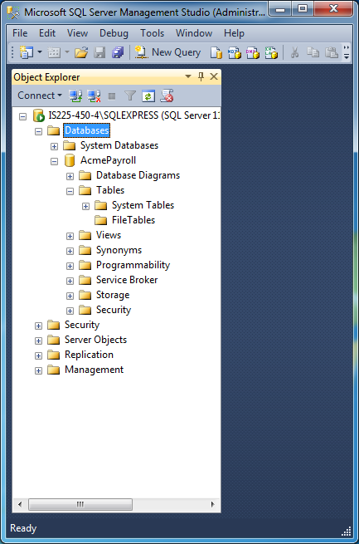
- Using the ODBC Data Source Administrator tool (under Control Panel → Administrative Tools on your Windows computer) create a System DSN entry of type ‘SQL Native Client’ that connects to the AcmePayroll database in your SQL Server Express instance (from step 1 above). Take a screen shot of the System DSN entry setup screen after you have specified the link parameters (i.e., the screen that has the ‘Test Connection’ button) and post it here:
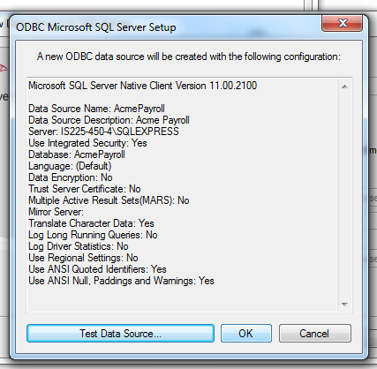
- Now from inside MS-Access, export your data tables to the SQL Server Express database you have created for AcmePayroll. Take another screen shot of the Tools program after you can see the tables inside the database (and post the screen shot here):
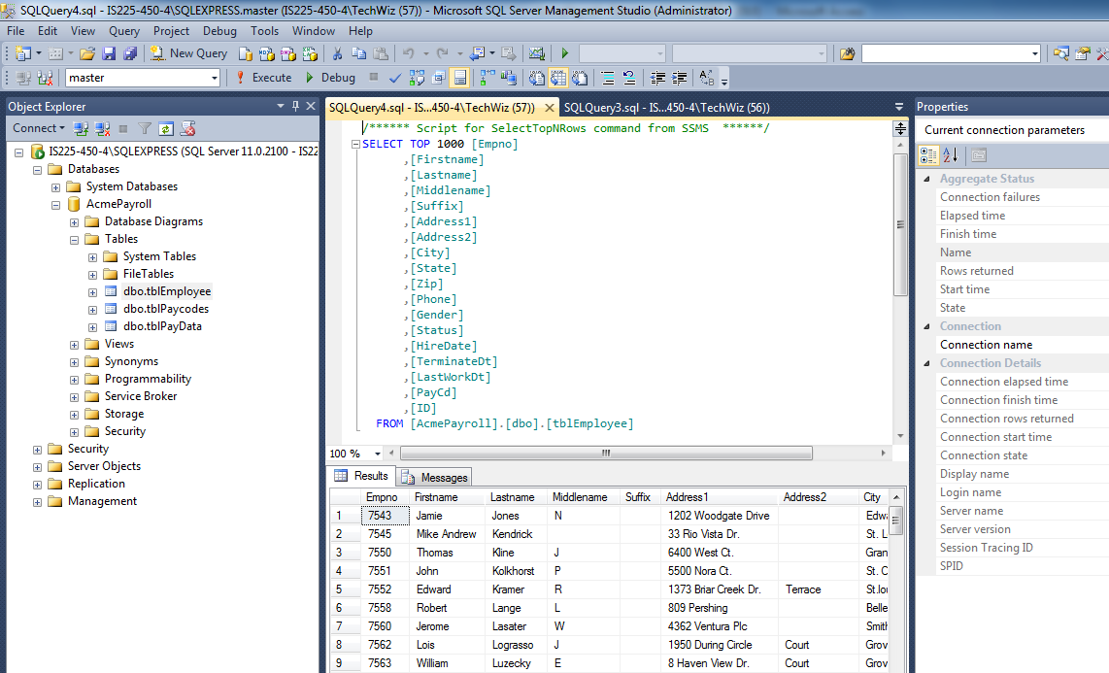
Part 2: ClubDB
- Build a database called ClubDB in your SQL Server Express DB and, using the ‘.sql’ files provided with this lab, use the Management Tools program to create and populate three database tables (members, codes, and purchases). Take a screen shot of the Management Tools screen showing the database with the tables after creation (post screen shot here):
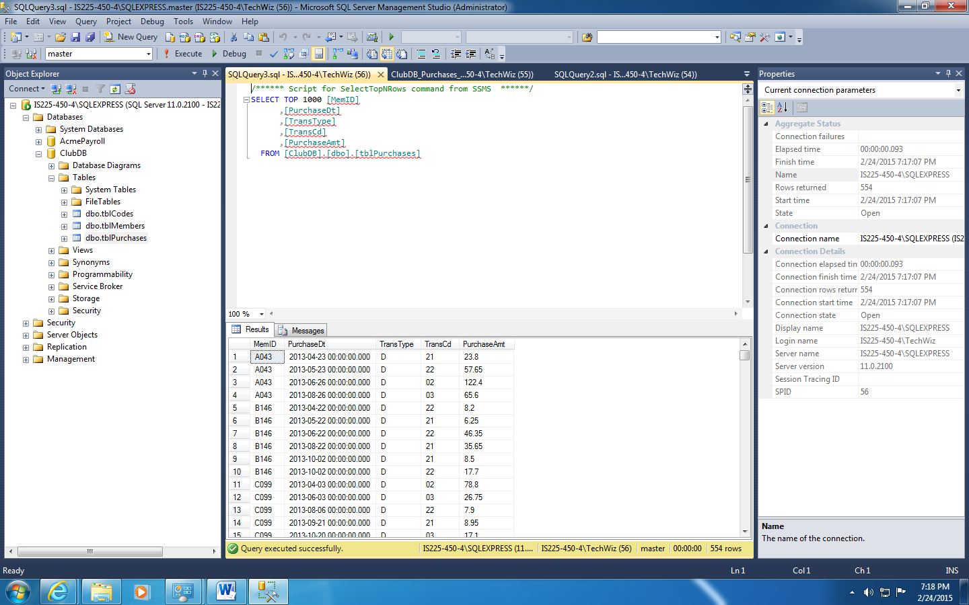
- Using the Management Tools program define primary keys for the Codes and Members table, as follows:
    - tblCodes: TransCd
    - tblMembers: MemID
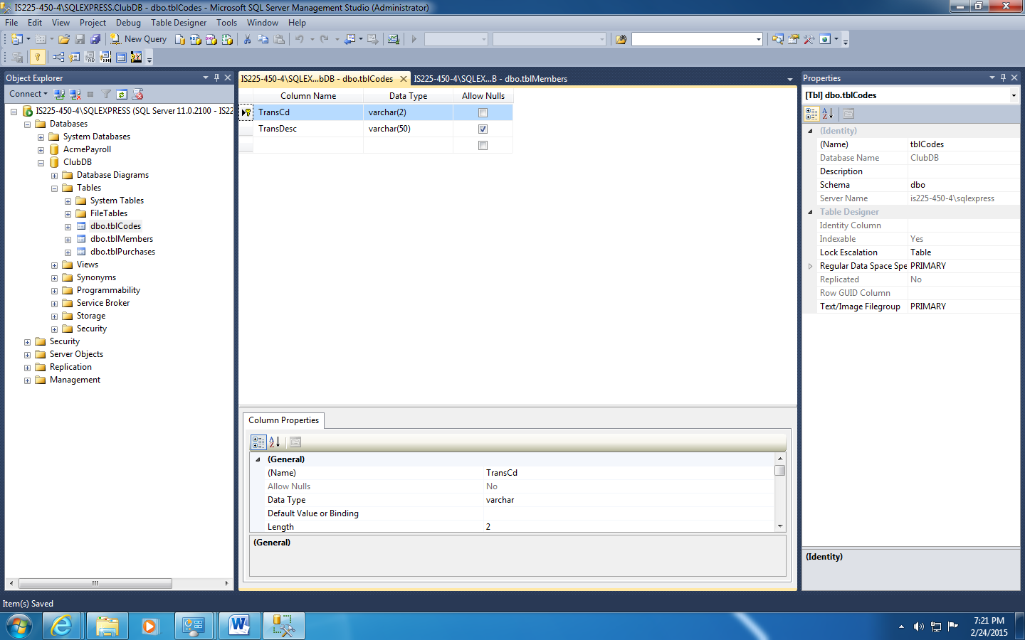
- What is the problem with creating a primary key for tblPurchases? Determine a solution and indicate it here, and post a screen shot of the ‘design’ screen for tblPurchases (inside Management Tools):
Problem: no set of fields in a record can guarantee a unique data identifier.
Solution: create a new field that is a unique identifier.
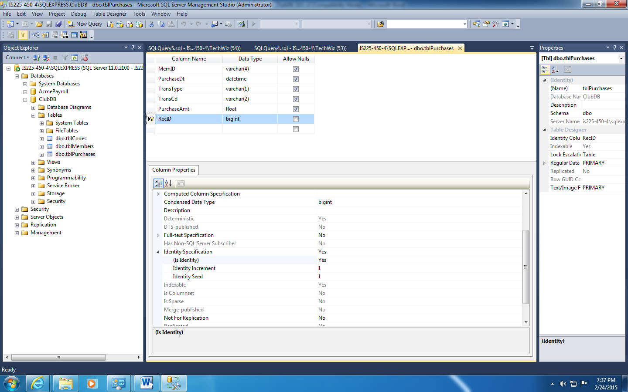
- Again using the Management Tools program, display the ‘Top 1000’ records of the tblMembers table after creation and data load:
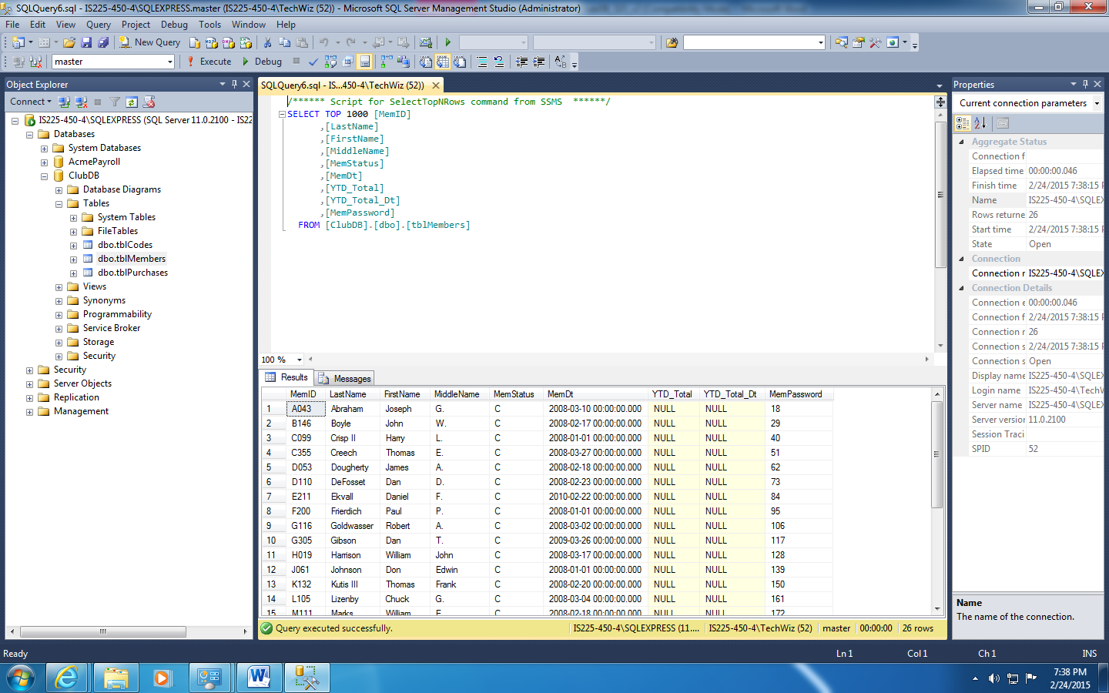
- Using the ODBC Data Source Administrator tool (under Control Panel → Administrative Tools on your Windows computer) create a System DSN entry of type ‘SQL Native Client’ that connects to the ClubDB database in your SQL Server Express instance. Take a screen shot of the System DSN entry setup screen after you have specified the parameters (i.e., the screen that has the ‘Test Connection’ button) and post it here:
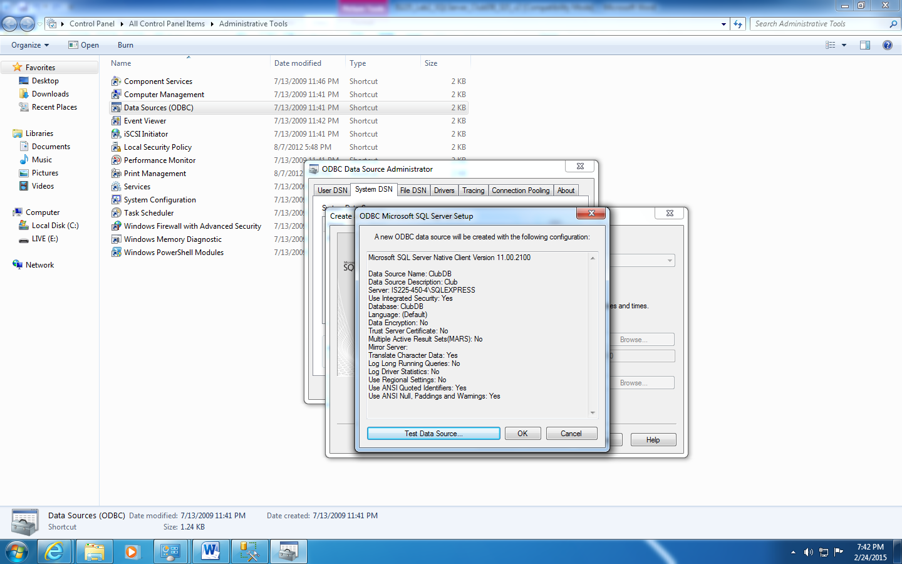
- Create a new MS-Access 2010 database called ClubDB and use the linking feature to connect (via the System DSN for ClubDB) to the tables in the ClubDB database inside SQL Server Express.
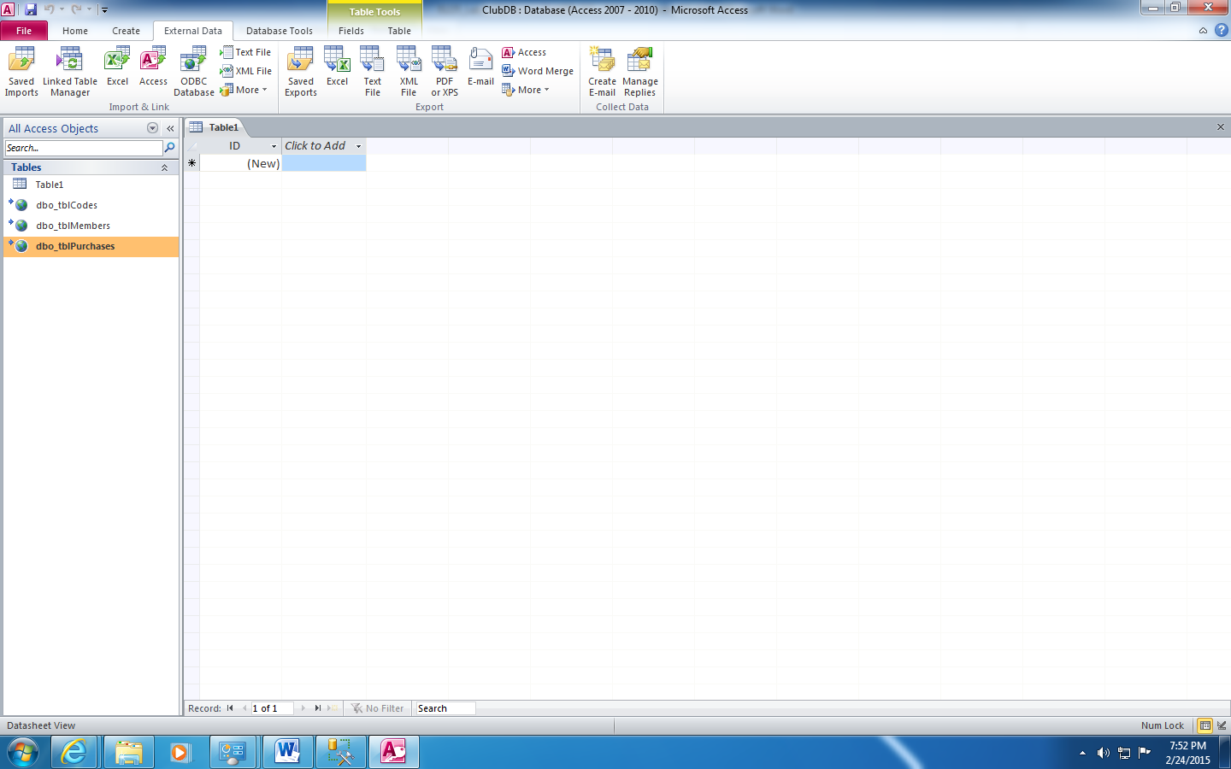

- Create the following queries inside your Access database for ClubDB:
  - A query showing the transaction detail for each member, as follows:
    - From tblMembers: MemID, and composite Name Field (last, first, middle)
    - From tblPurchases: all fields
    - From tblCodes: the transaction description (put it next to the TransCd from tblpurchases)
    - Sort by MemID
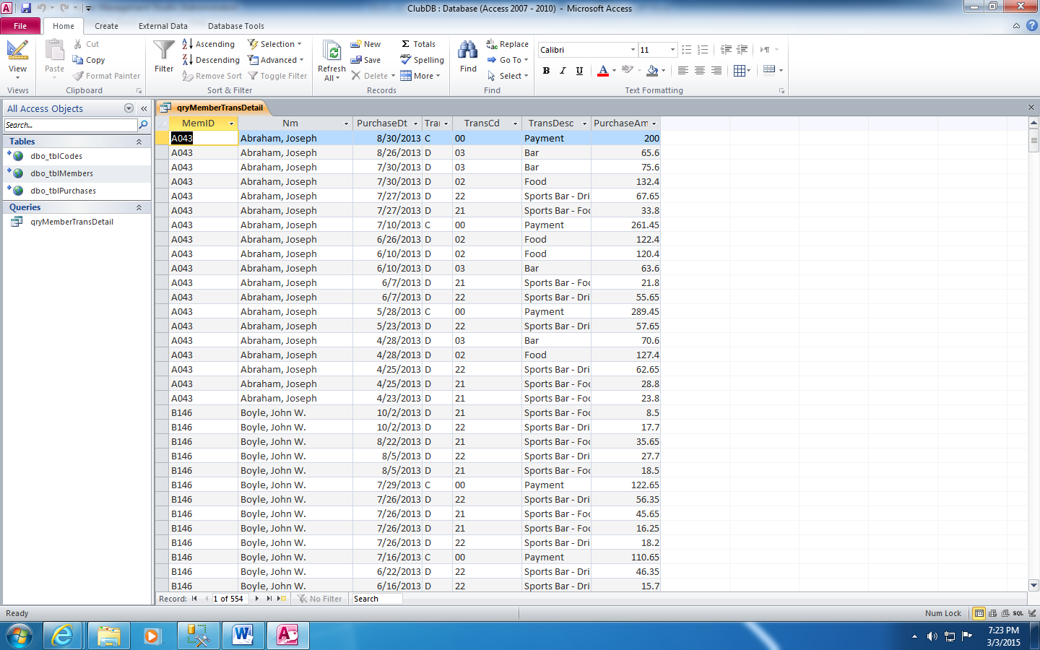
  - A totaling query based on the query above which shows the total amount purchased and the total payments made for each member (i.e., two lines per member):
    - From tblMembers: MemID and composite Name
    - From tblPurchases: a count of the number of transactions in each category, plus the last transaction date for each category, and a total for each category.
    - The categories are based on the TransType field in tblPurchases: Type ‘D’ transactions are purchases while type ‘C’ transactions are payments (all amounts are positive values).
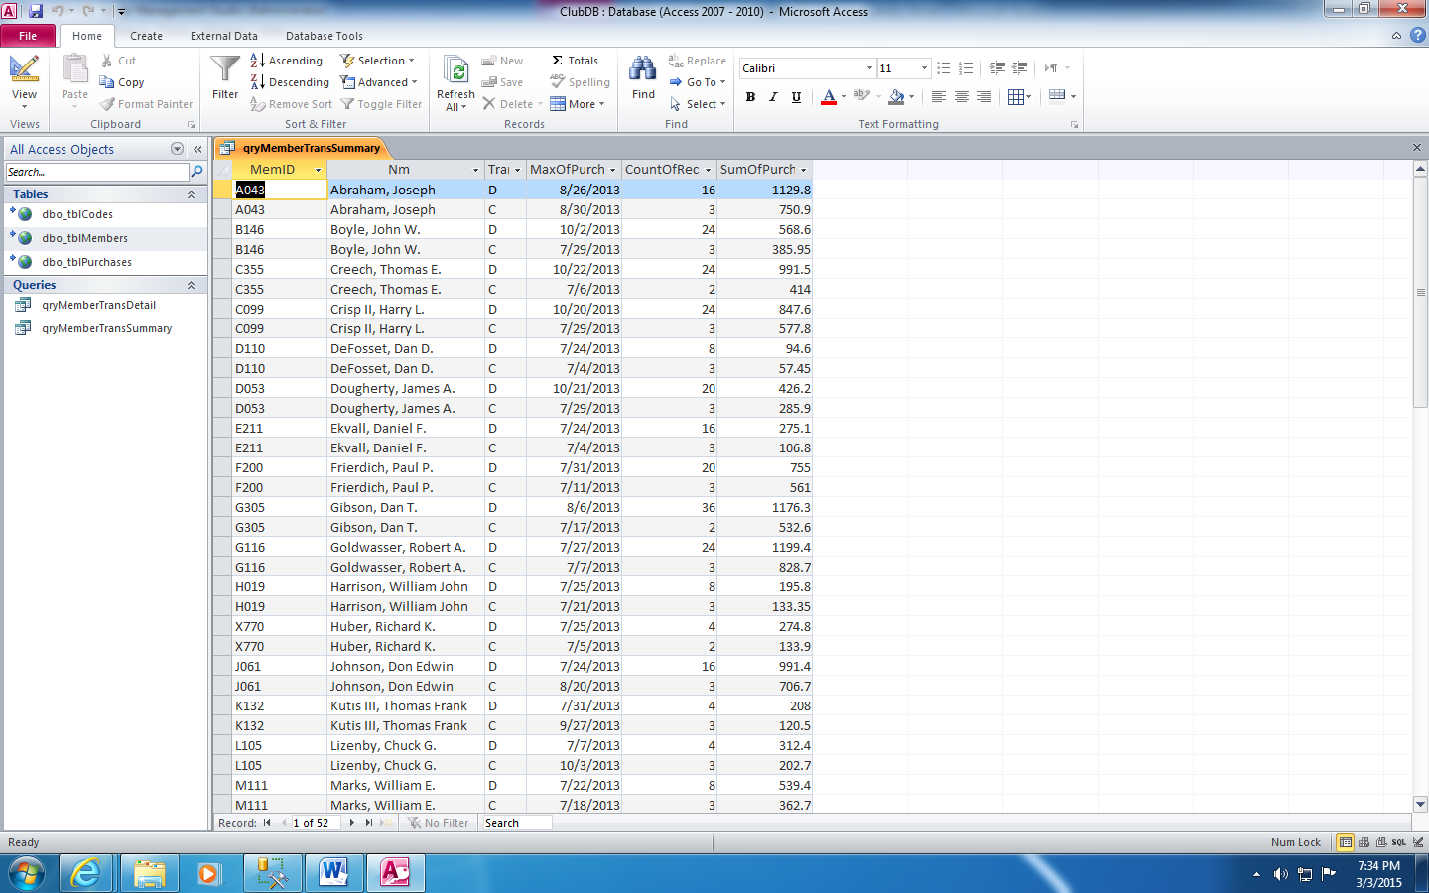
  - An update query which posts the proper values to the tblMember table for “YTD_Total” and “YTD_Total_Dt”. YTD_Total is the total amount due for the member, while YTD_Total_Dt is the most recent transaction date for the member.
    - Note that you will have to adjust the totaling formula so that ‘D’ type transactions are positive (i.e., amounts owed) but ‘C’ type transactions, which are payments, must now be subtracted from the amount owed.
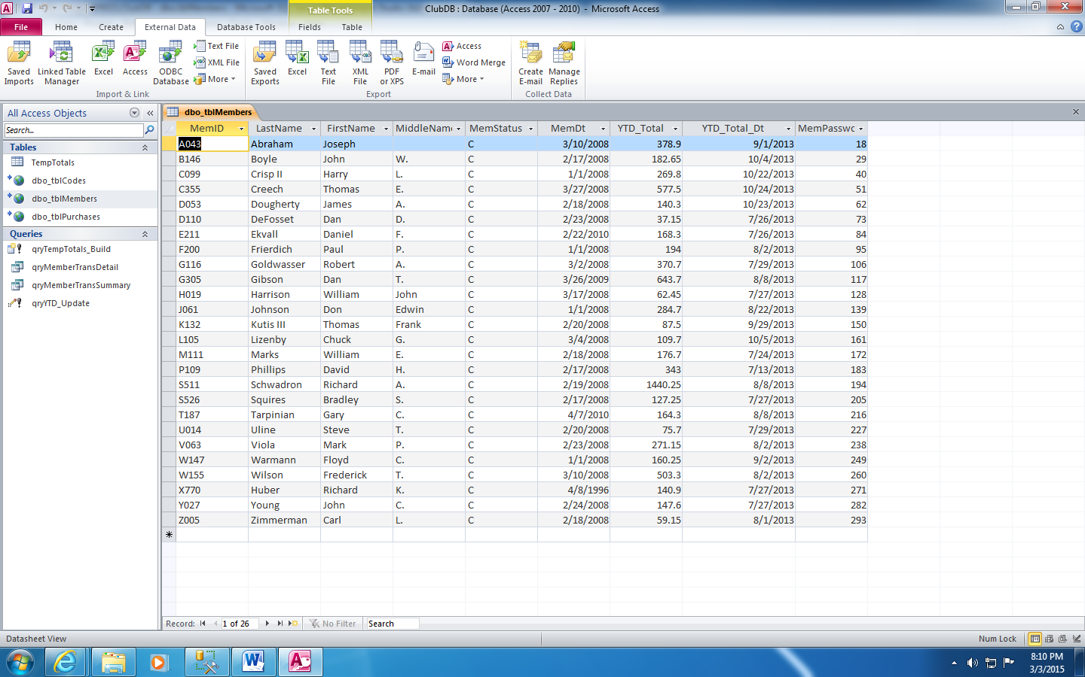
Added 2/24/15:
  - Develop a query which totals sales by transaction code. There should be one line per TransCd. The output line should be:
    - TransCd (tblPurchases), TransDesc (tblCodes), Count of Sales, Total of Sales
    - Count of Sales is calculated by counting the number of TransCd entries in tblPurchases for each code
    - Total of Sales is the sum of all the purchase amounts for each record in tblPurchases (separated out by TransCd)
    - Display totals only for codes: 02, 03, 21, and 22 (Food and Bar items)
    - Sort by TransCd

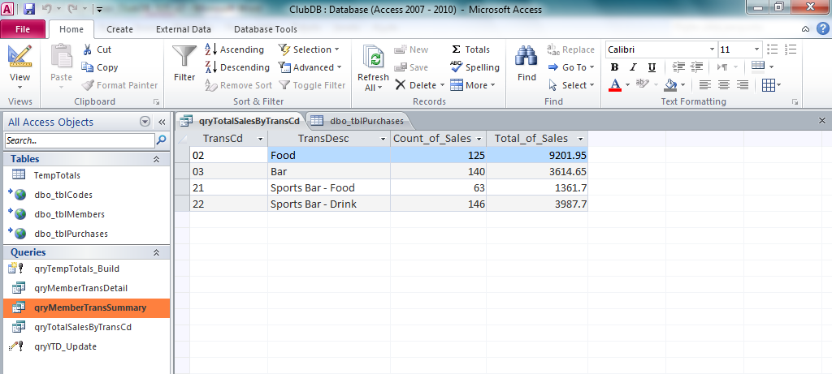

11. What does "Last" do? (EXTRA CREDIT)
Last: Microsoft Access uses the Last() function to get the last occurrence of a value in a category.

Submission requirements:
For this lab you will need to submit both this document (with requested screen shots added) plus your MS-Access ClubDB.accdb database file.

